IT457 Cloud computing

Assignment - 4

Abhinav Agarwal (202101040)

**1. Create NoSQL Azure Table storage design for the following problems and implement crud operations using your opted language SDK to validate the working of the design.**

a. A gift shop wants to start a portal which allows users to view various items present in its store. The items details like name, price, available quantity etc. are shown. Along with that, pictures of item from different angles are also available. There’s a high-res image also available for every item:

**2. Complete the following tutorials**:

a. Develop an ASP.NET web application with Azure Cosmos DB for NoSQL:

Keys in Cosmos DB account: -

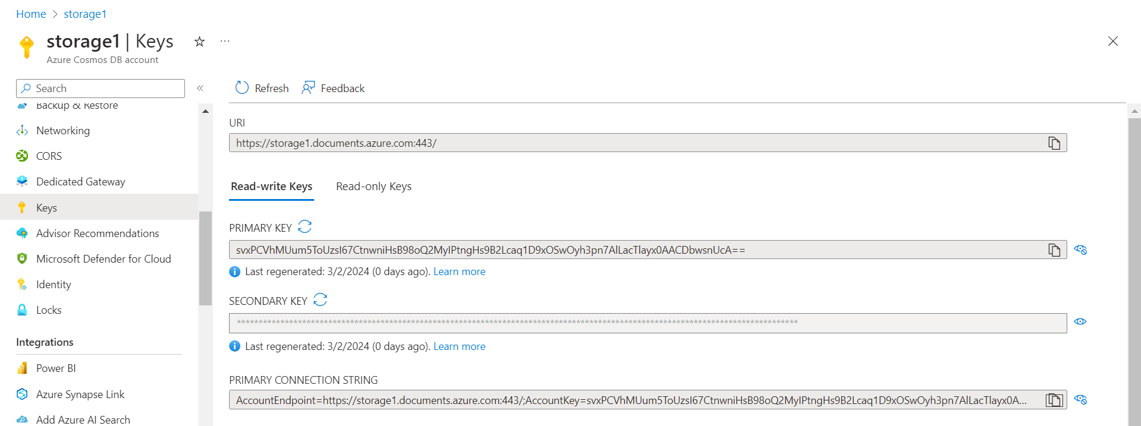

Data Population: -

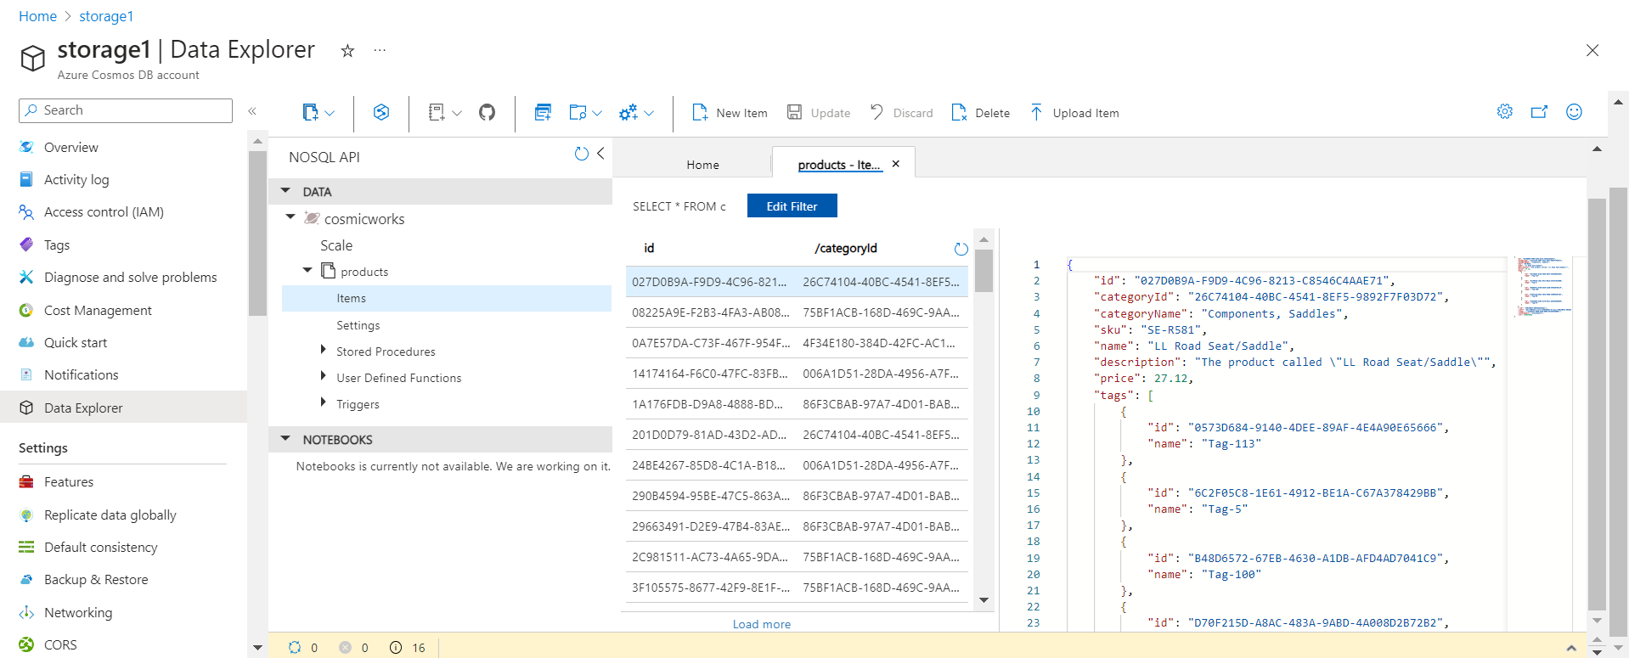

Query Executions: -

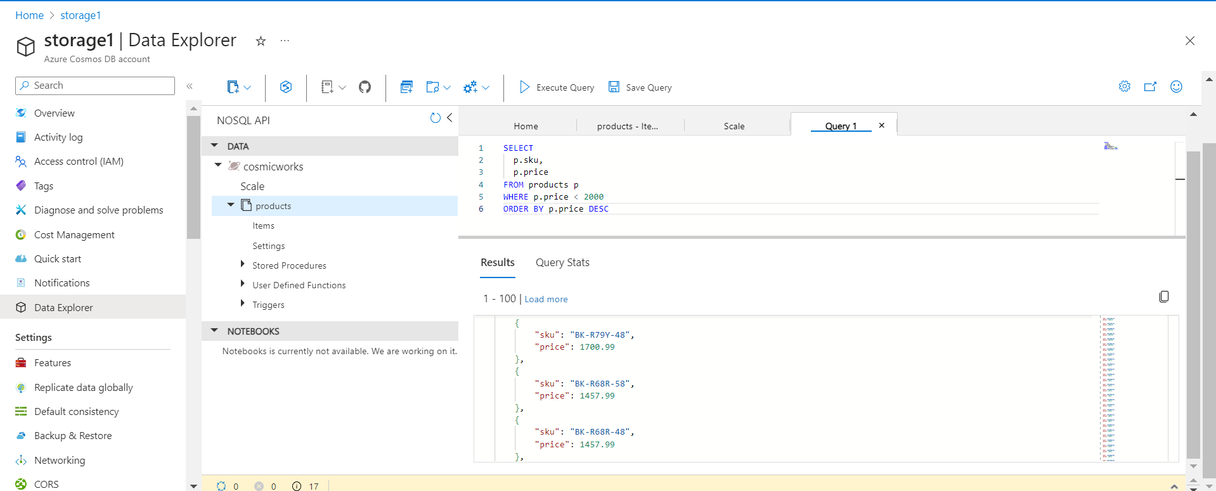

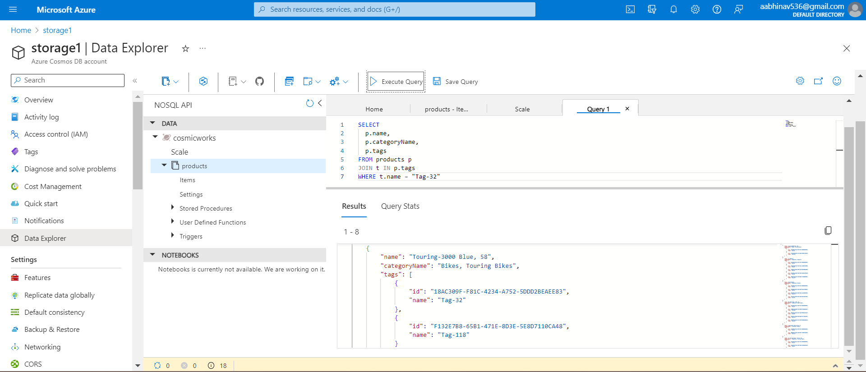

Building and running application:-

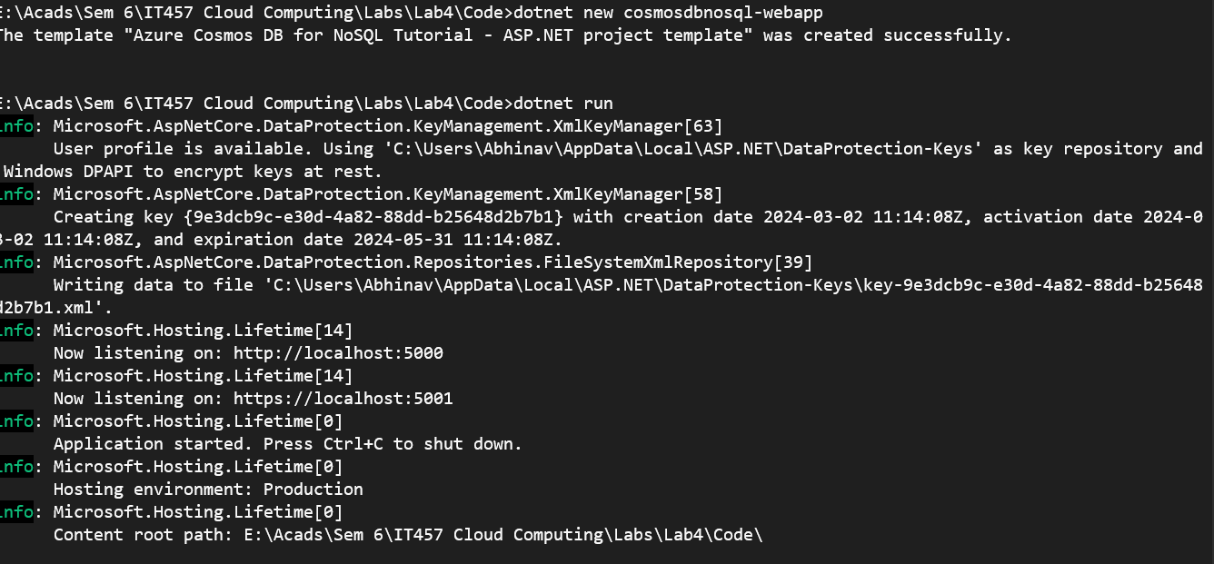

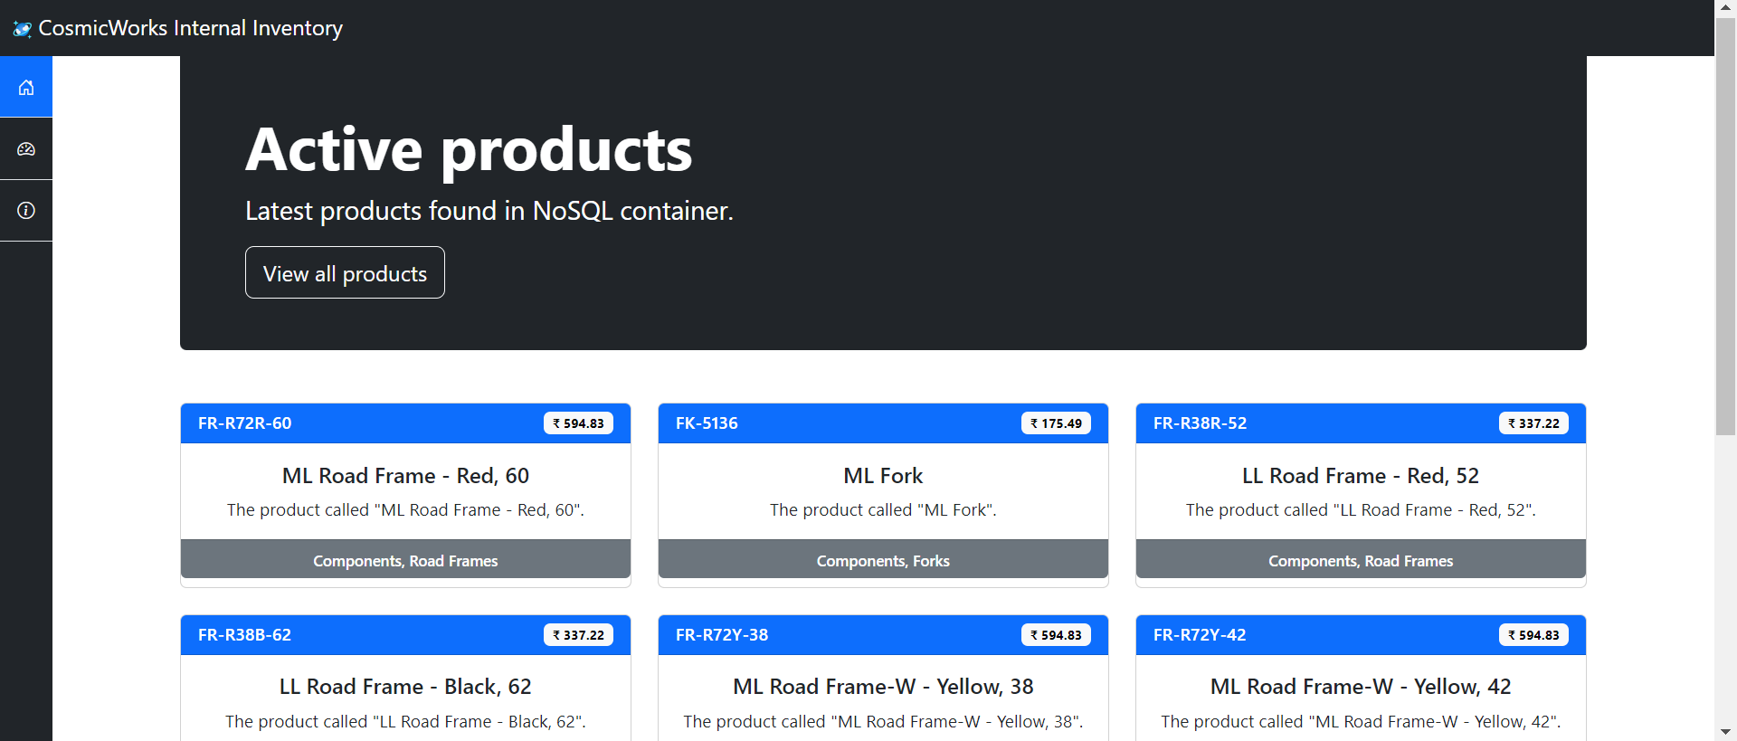

Adding code and running the application: -

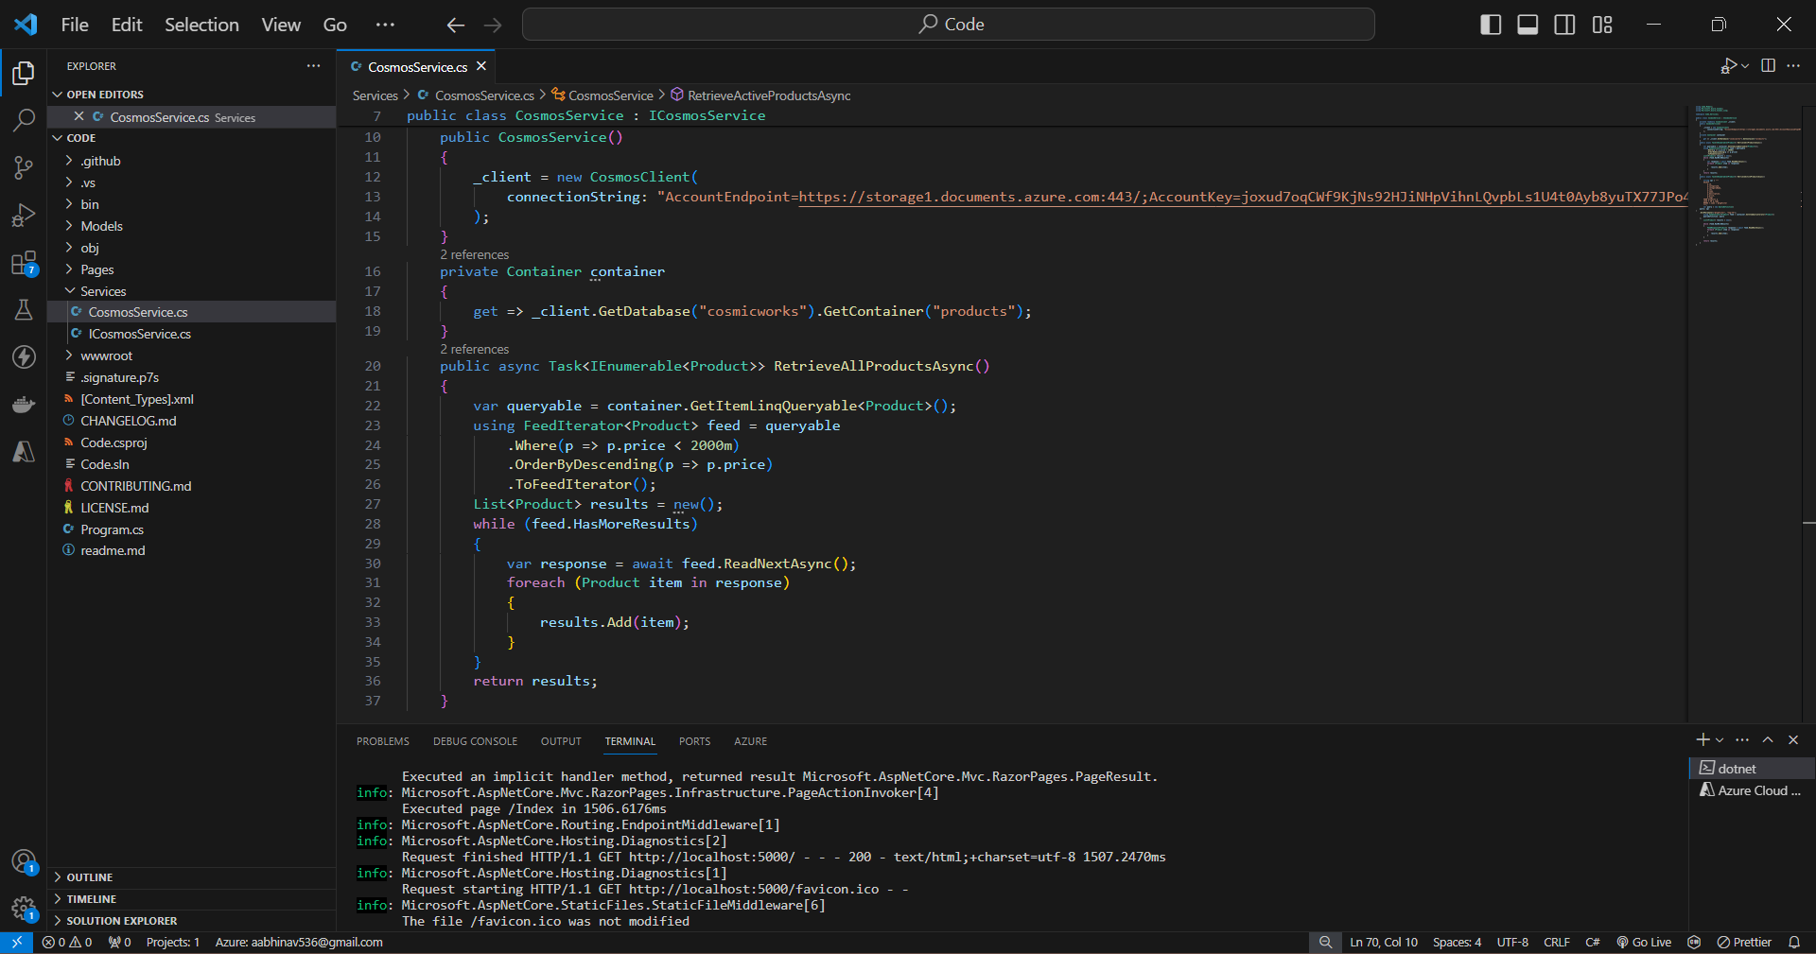

Updated List of items in decreasing order of prices from the azure cosmos DB database: -

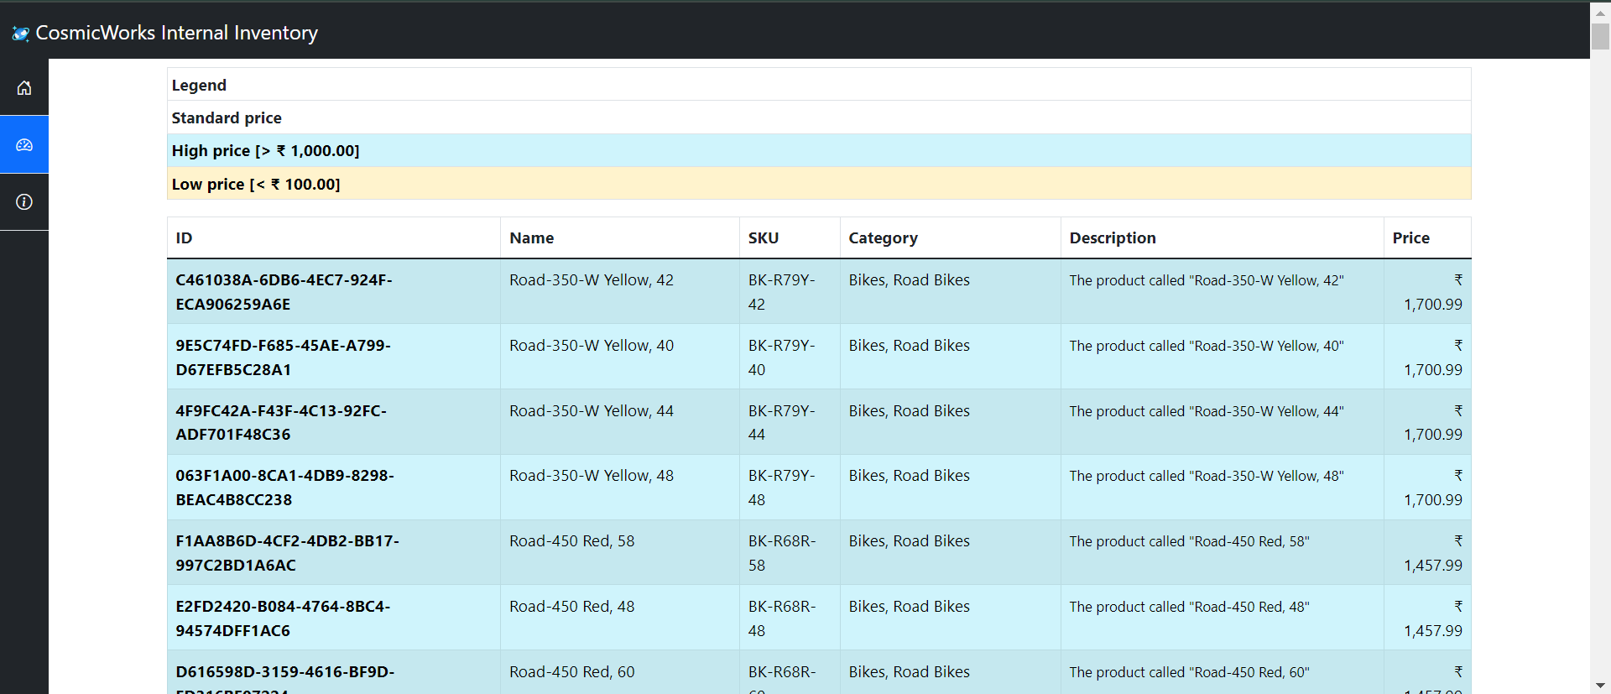

b. Azure Cosmos DB – end to end example:

Storage account, database, container, and items: -

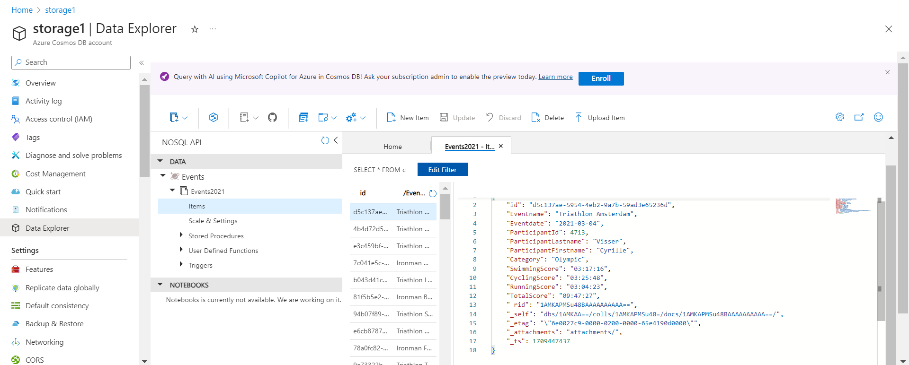

Executing query: -

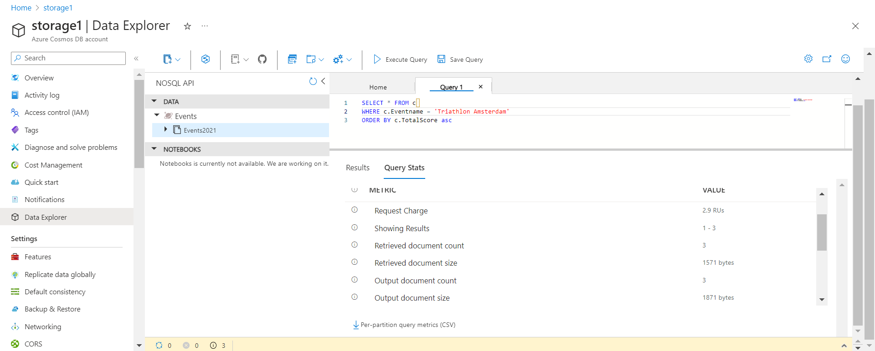

Old indexing policy: -

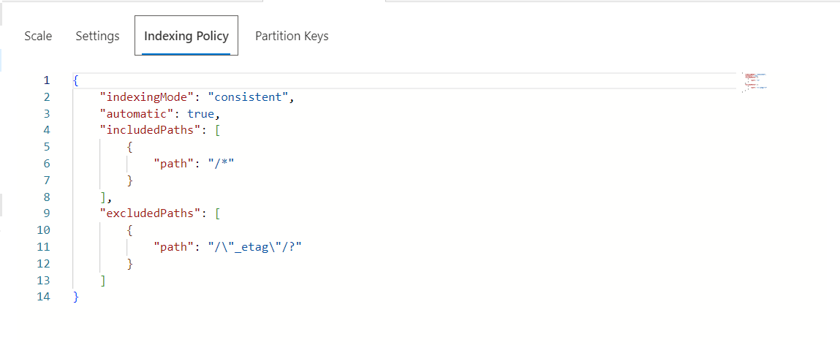

New indexing policy: -

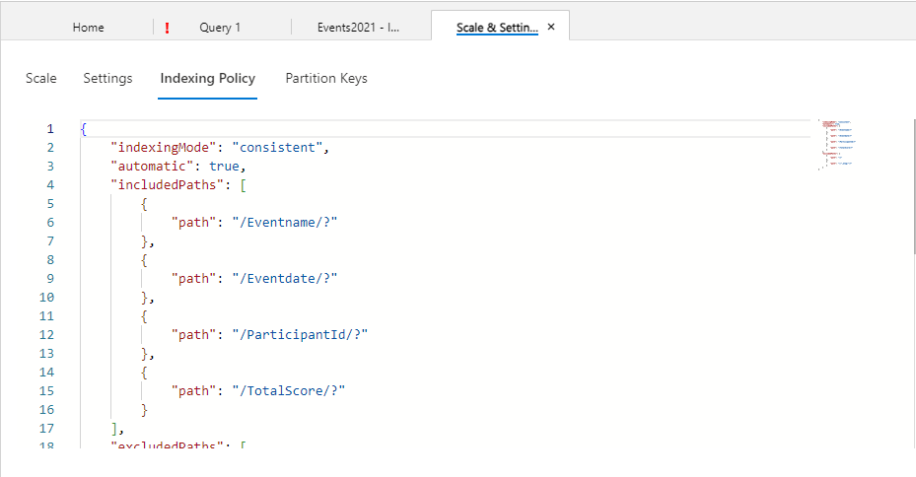

Optimised querying: -  
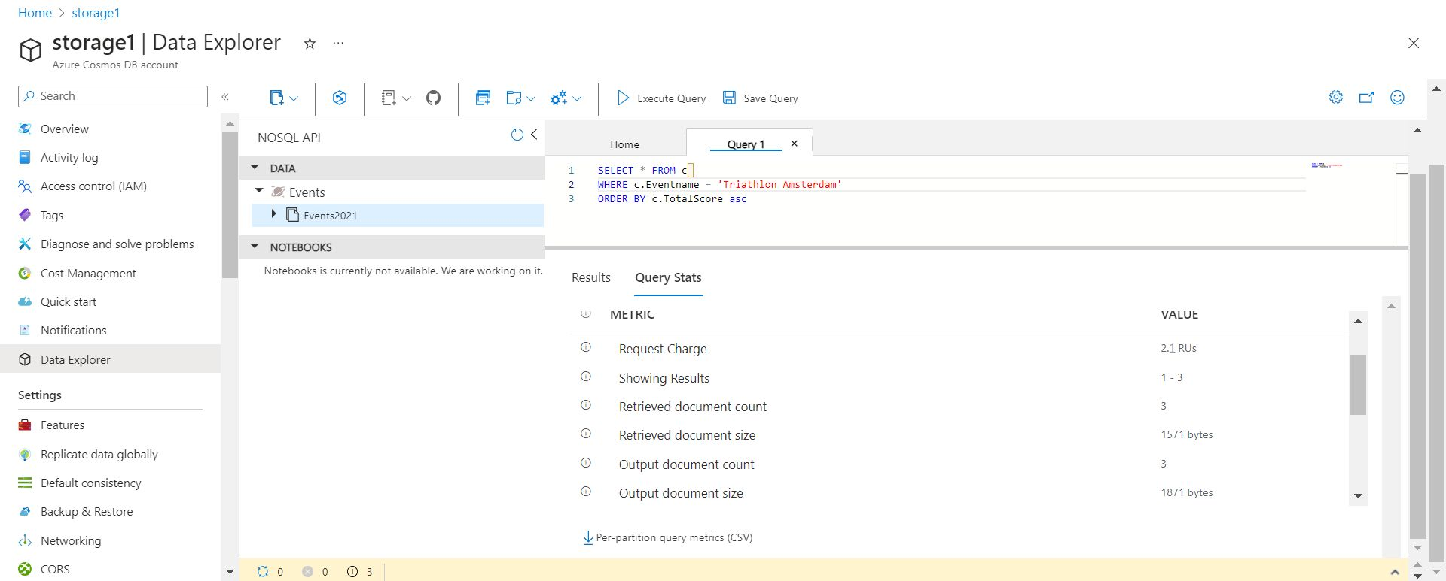

c. Azure Cosmos DB for Table for .NET

Creating Cosmos DB account using Azure PowerShell:

l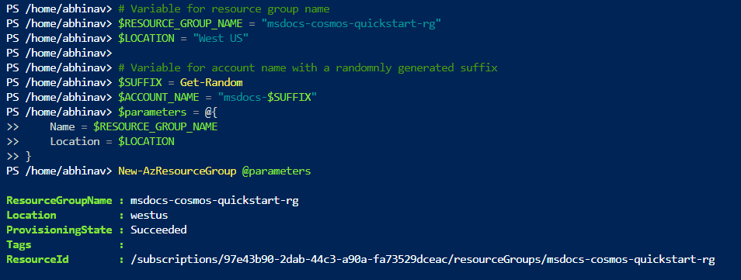

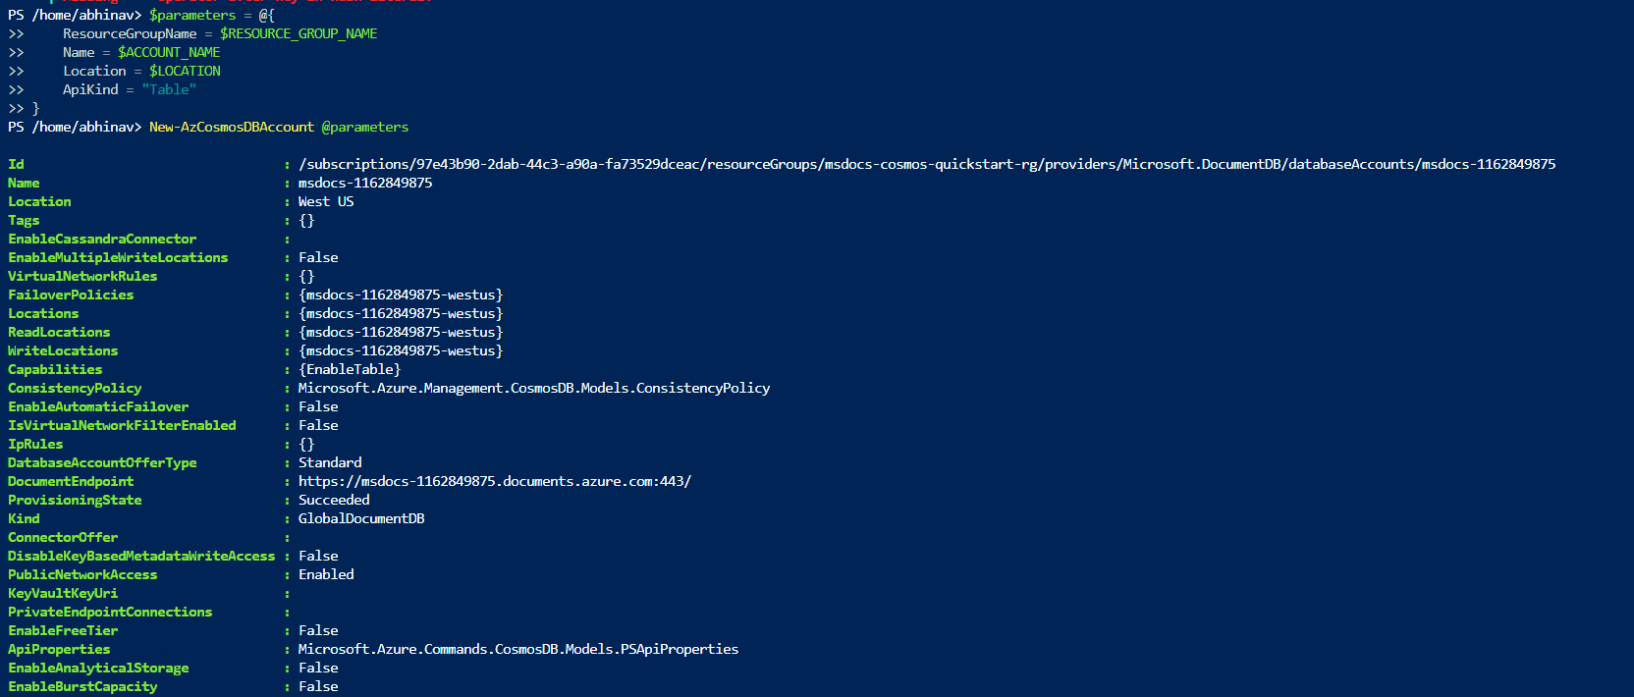

Getting document endpoints: -

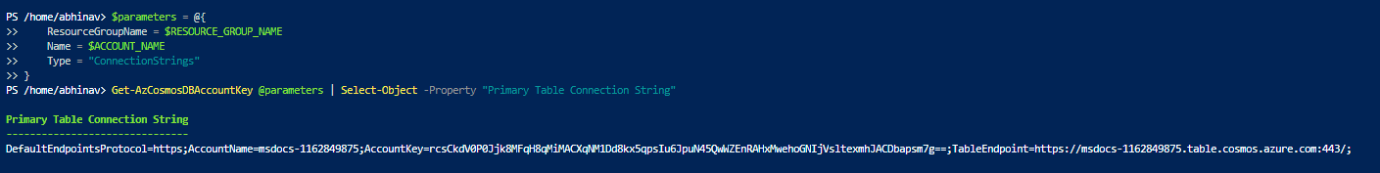

Code: -

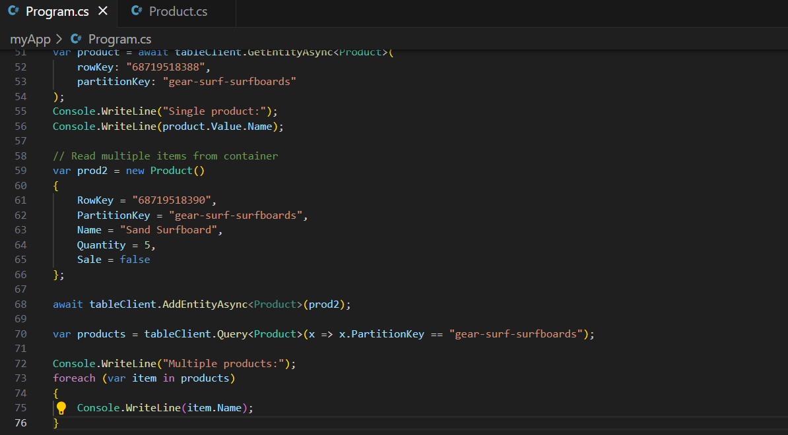

Output: -

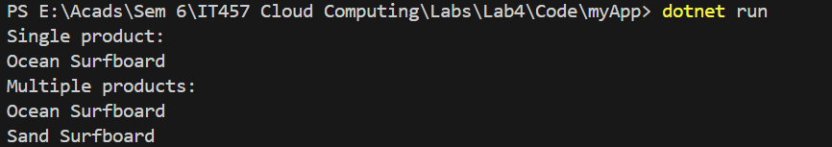

Output on Azure portal: -

